DIS-AM,C-Cemi-Bird-7.5 in.

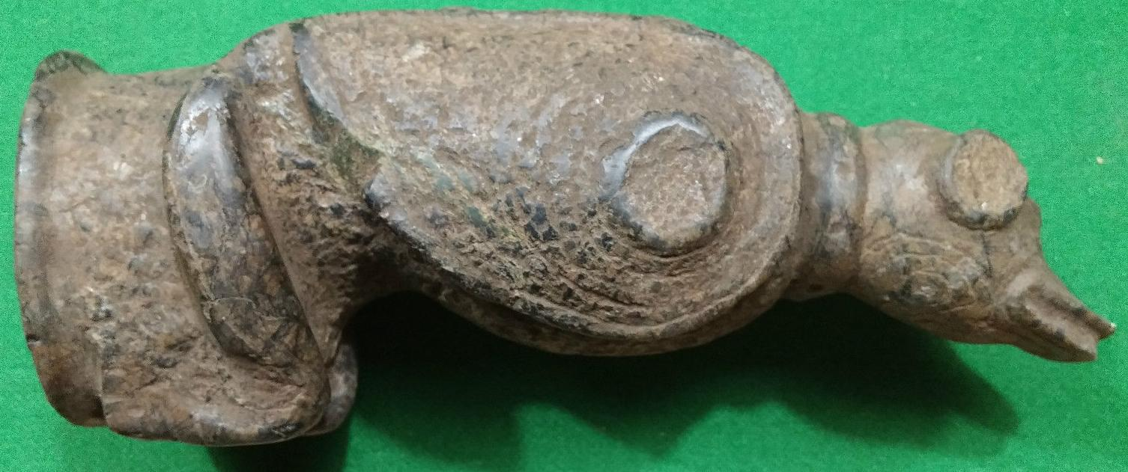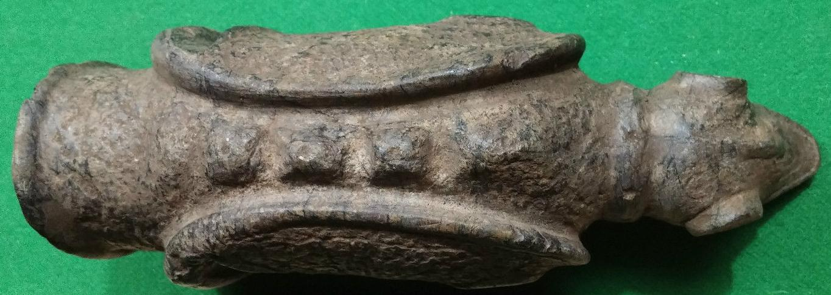

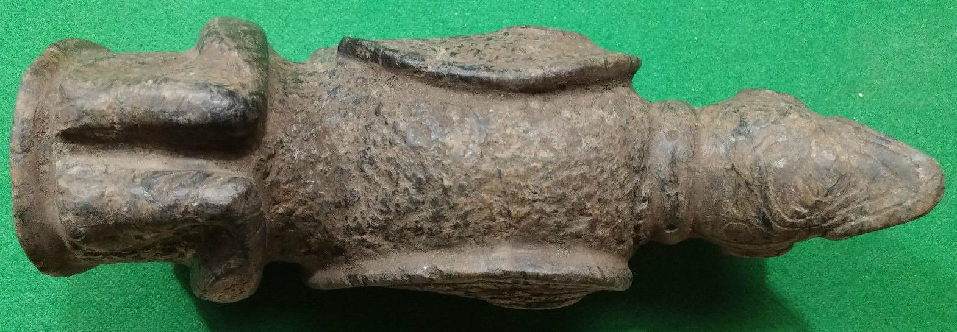

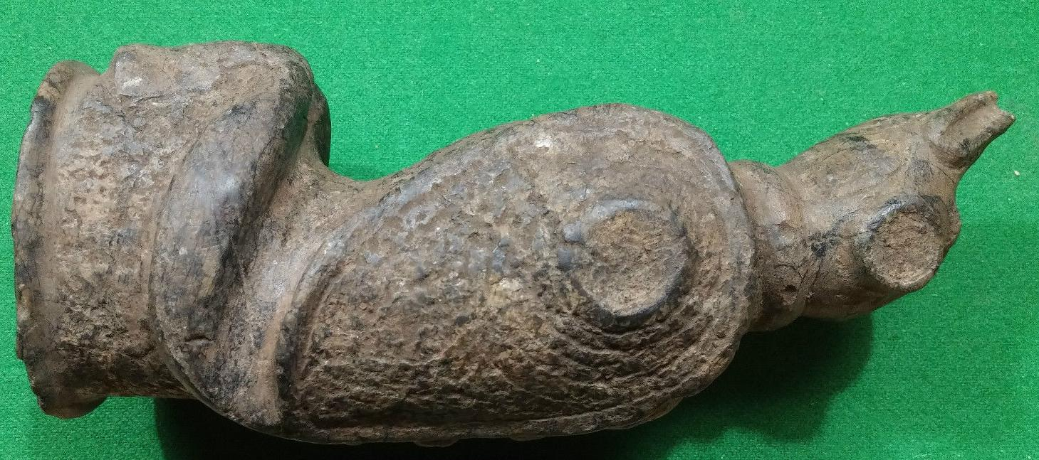

Sold by [user1billion](http://myworld.ebay.com/user1billion) ( [823](http://feedback.ebay.com/ws/eBayISAPI.dll?ViewFeedback&userid=user1billion) )

### Delivery package 1 of 1

Estimated delivery Wednesday, Mar 23, 2016 - Thursday, Mar 31, 2016



#### [Taino Stone Bird Hand Maul (Grinder) - Pre Columbian](http://www.ebay.com/itm/272153334517)

|  |  |
| --- | --- |
| Item price | $249.00 |
| Quantity | 1 |
| Item number | 272153334517 |
| Shipping service | Standard Int'l Shipping |

## Shipping address

Ralph J Coffman Jr

149 Atlantic Ave

Swampscott MA 01907-2427

United States

## Order total

|  |  |
| --- | --- |
| Subtotal | $473.95 |
| Shipping | $54.40 |

**Total**

$528.35

Order placed on

Friday, Mar 11, 2016

Payment method

PayPal

Payment date

Friday, Mar 11, 2016